Unexplored Winds: Evaluating Wind Energy Potential in an Emerging Region—Anantapur, India

Introduction
Wind energy is a rapidly growing renewable energy source in India, contributing significantly to sustainable power generation. While established wind hubs such as Tamil Nadu dominate installed capacity, emerging regions like Anantapur in Andhra Pradesh are gaining attention due to favorable wind conditions and availability of land.
This study evaluates the wind energy potential of Anantapur using data analytics techniques by analyzing one year of wind speed data and estimating power generation patterns. The objective is to understand temporal variations, seasonal trends, and the feasibility of wind energy development in this region.

Data Collection & Understanding
The dataset used in this study was obtained from the NASA POWER database using geographic coordinates of Anantapur (14.68°N, 77.60°E). Daily data for the year 2025 was collected.
The key variables used include:
- Wind Speed at 50 meters (WS50M), representing turbine hub height
- Wind Speed at 10 meters (WS10M) for comparison
- Temperature at 2 meters (T2M) for environmental context
Wind speed at 50 meters was selected as the primary variable as it closely represents real-world wind turbine operating conditions.

Data Cleaning & Preprocessing
The dataset initially contained separate columns for year, month, and day, which were combined to form a unified date column for time-series analysis.
The dataset was checked for missing values, and no null values were found across any variables, indicating that the data is complete and reliable.
Additional features were created to enhance analysis. Estimated power output was calculated using the cubic relationship between wind speed and power. The dataset was also structured to enable monthly aggregation for seasonal analysis.

Data Analysis & Techniques
Wind energy analysis was conducted using trend analysis, seasonal aggregation, and correlation techniques.
Daily wind speed trends were analyzed to understand variability over time. Monthly averages were computed to identify seasonal patterns. Estimated power output was calculated using the relationship:
$P α v³$
This relationship highlights the sensitivity of energy generation to wind speed. Correlation analysis was performed to examine relationships between wind speed, temperature, and estimated power output.

Visualization & Interpretation

Daily Wind Speed Variation in Anantapur
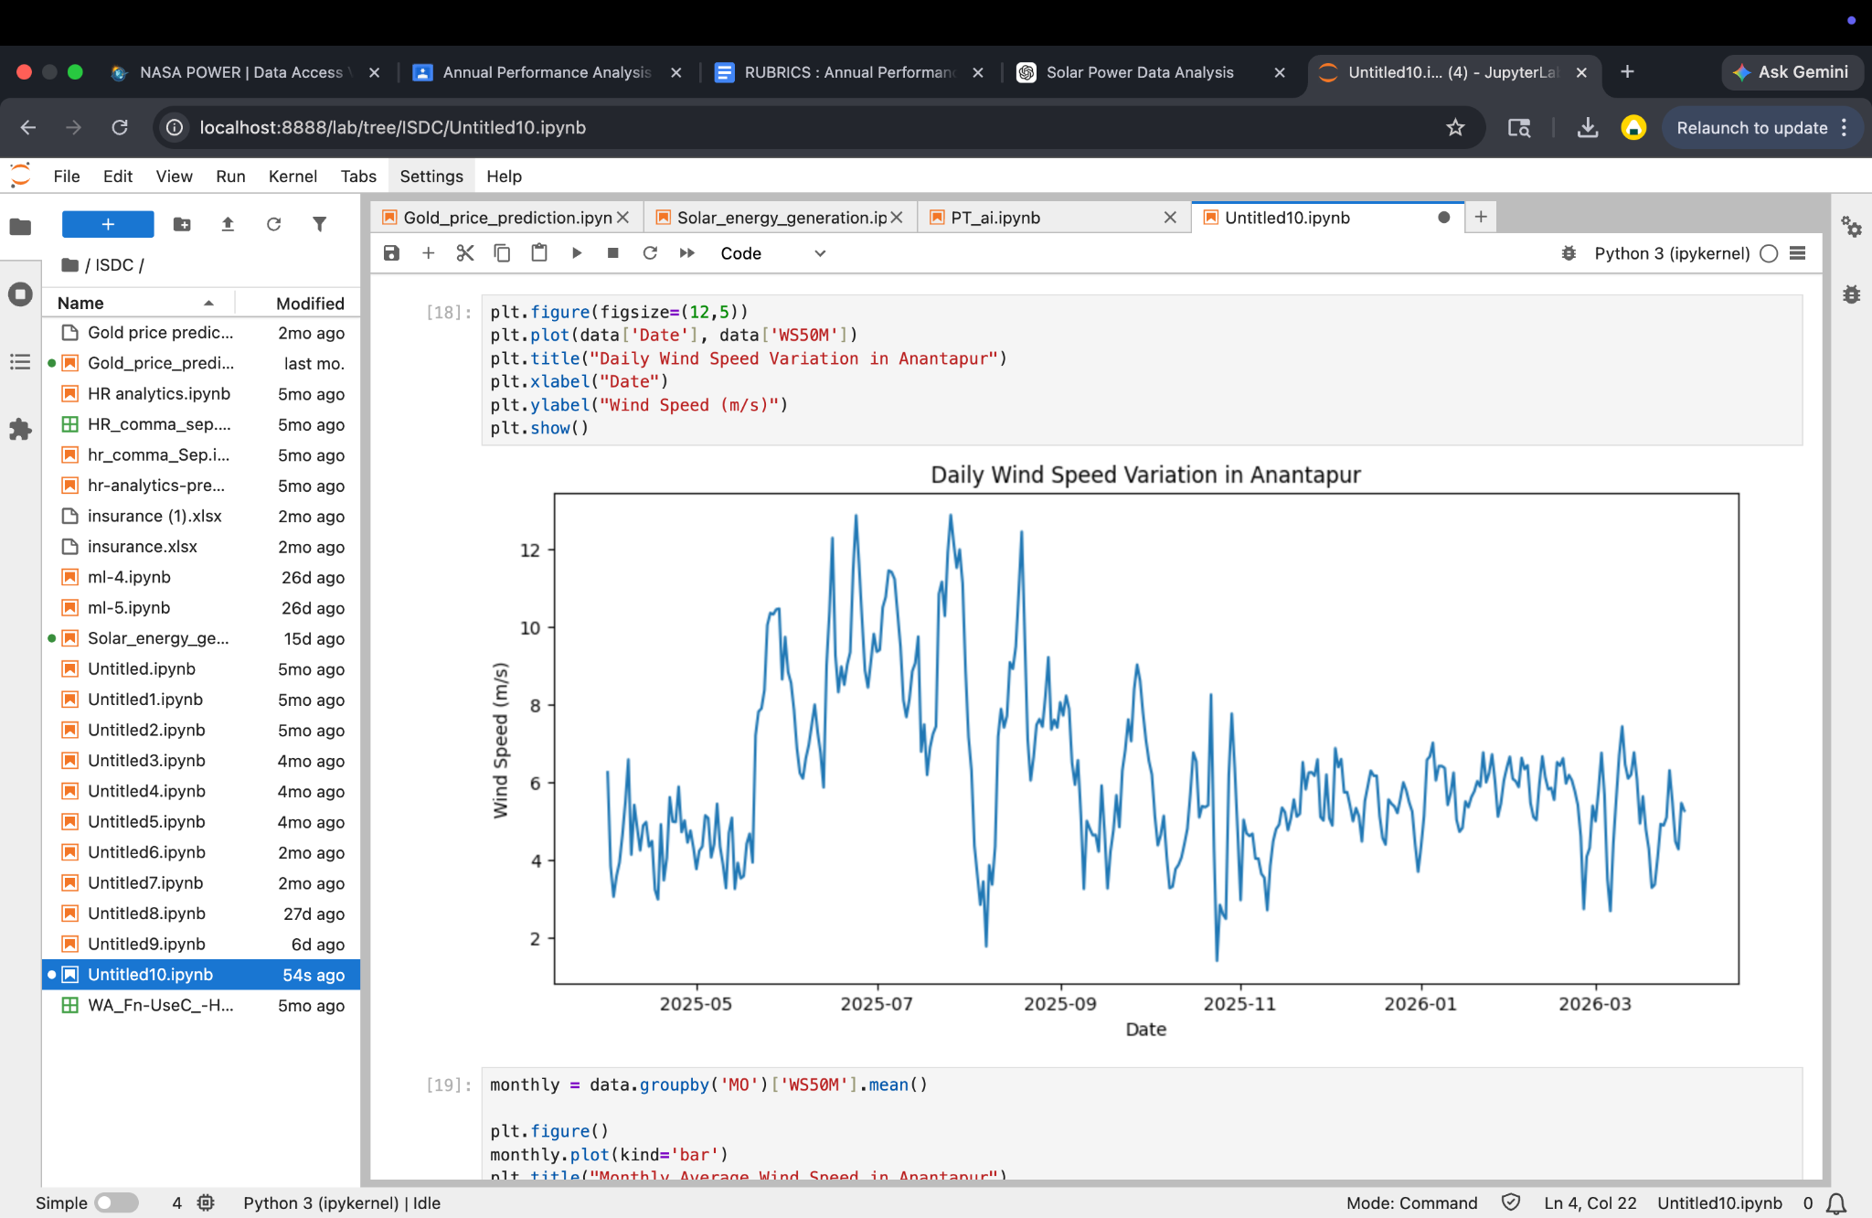
The daily wind speed trend shows moderate fluctuations throughout the year, with values generally ranging between 3 m/s and 12 m/s. A noticeable increase in wind speed is observed during the mid-year period, particularly between June and August.This indicates seasonal strengthening of wind patterns during the monsoon period. Outside this phase, wind speeds remain relatively stable but lower in magnitude, suggesting that while wind energy is consistently available, it varies significantly over time.

Monthly Average Wind Speed in Anantapur
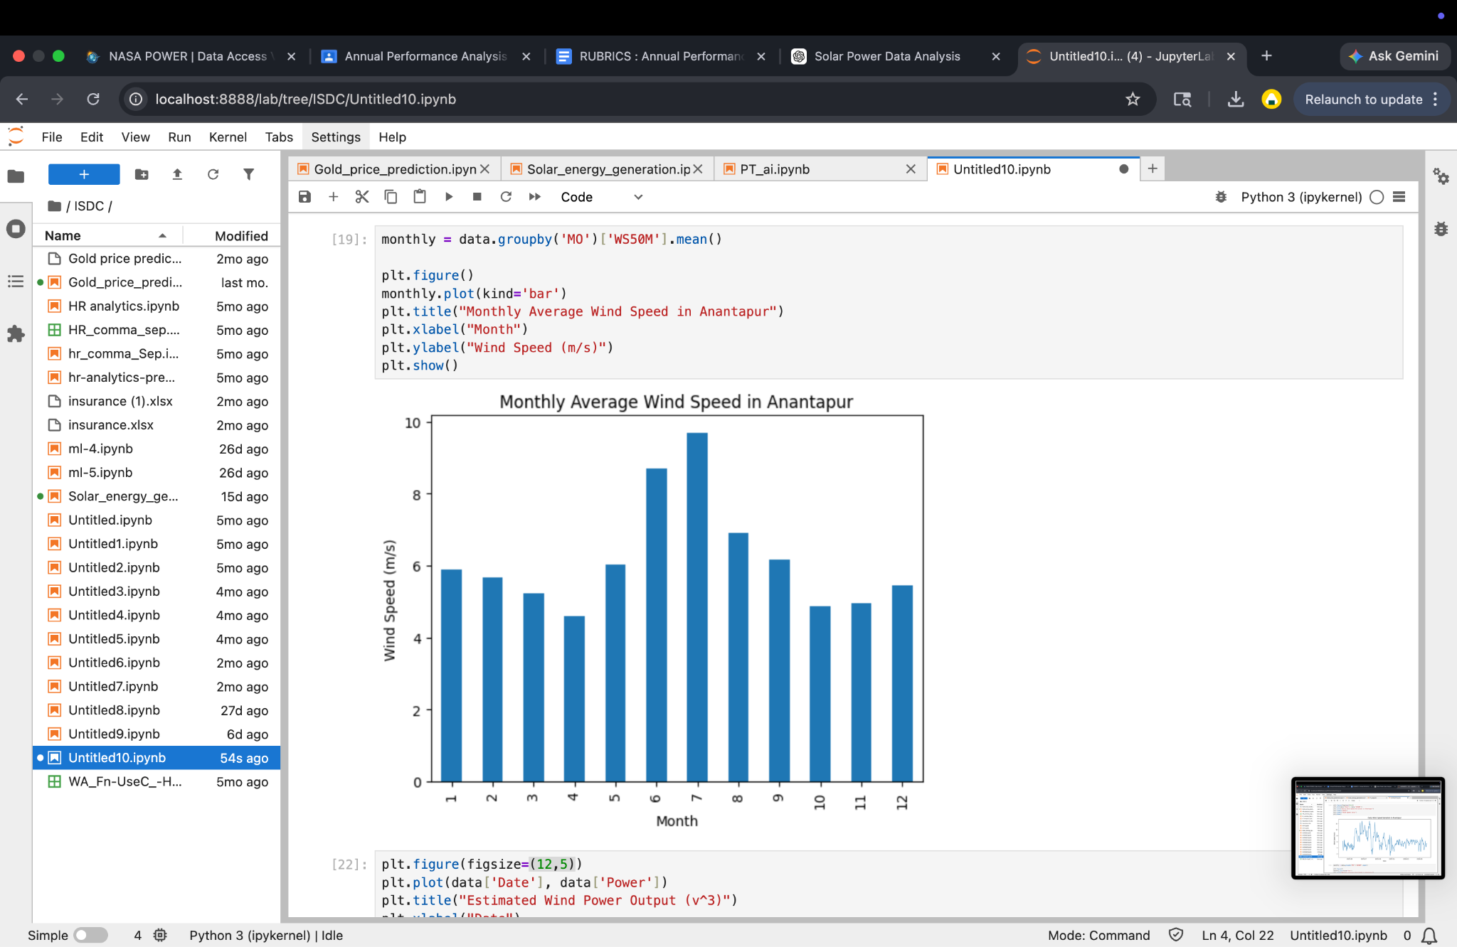
The monthly average wind speed graph clearly highlights seasonal variation in wind patterns. Wind speeds gradually increase from April, reach their peak during June and July (approximately 9–10 m/s), and then decline towards the end of the year. This pattern confirms the strong influence of monsoon winds in the region and identifies optimal periods for wind energy generation. The sustained high wind speeds during these months indicate maximum potential for energy production.

Estimated Wind Power Output (v³)
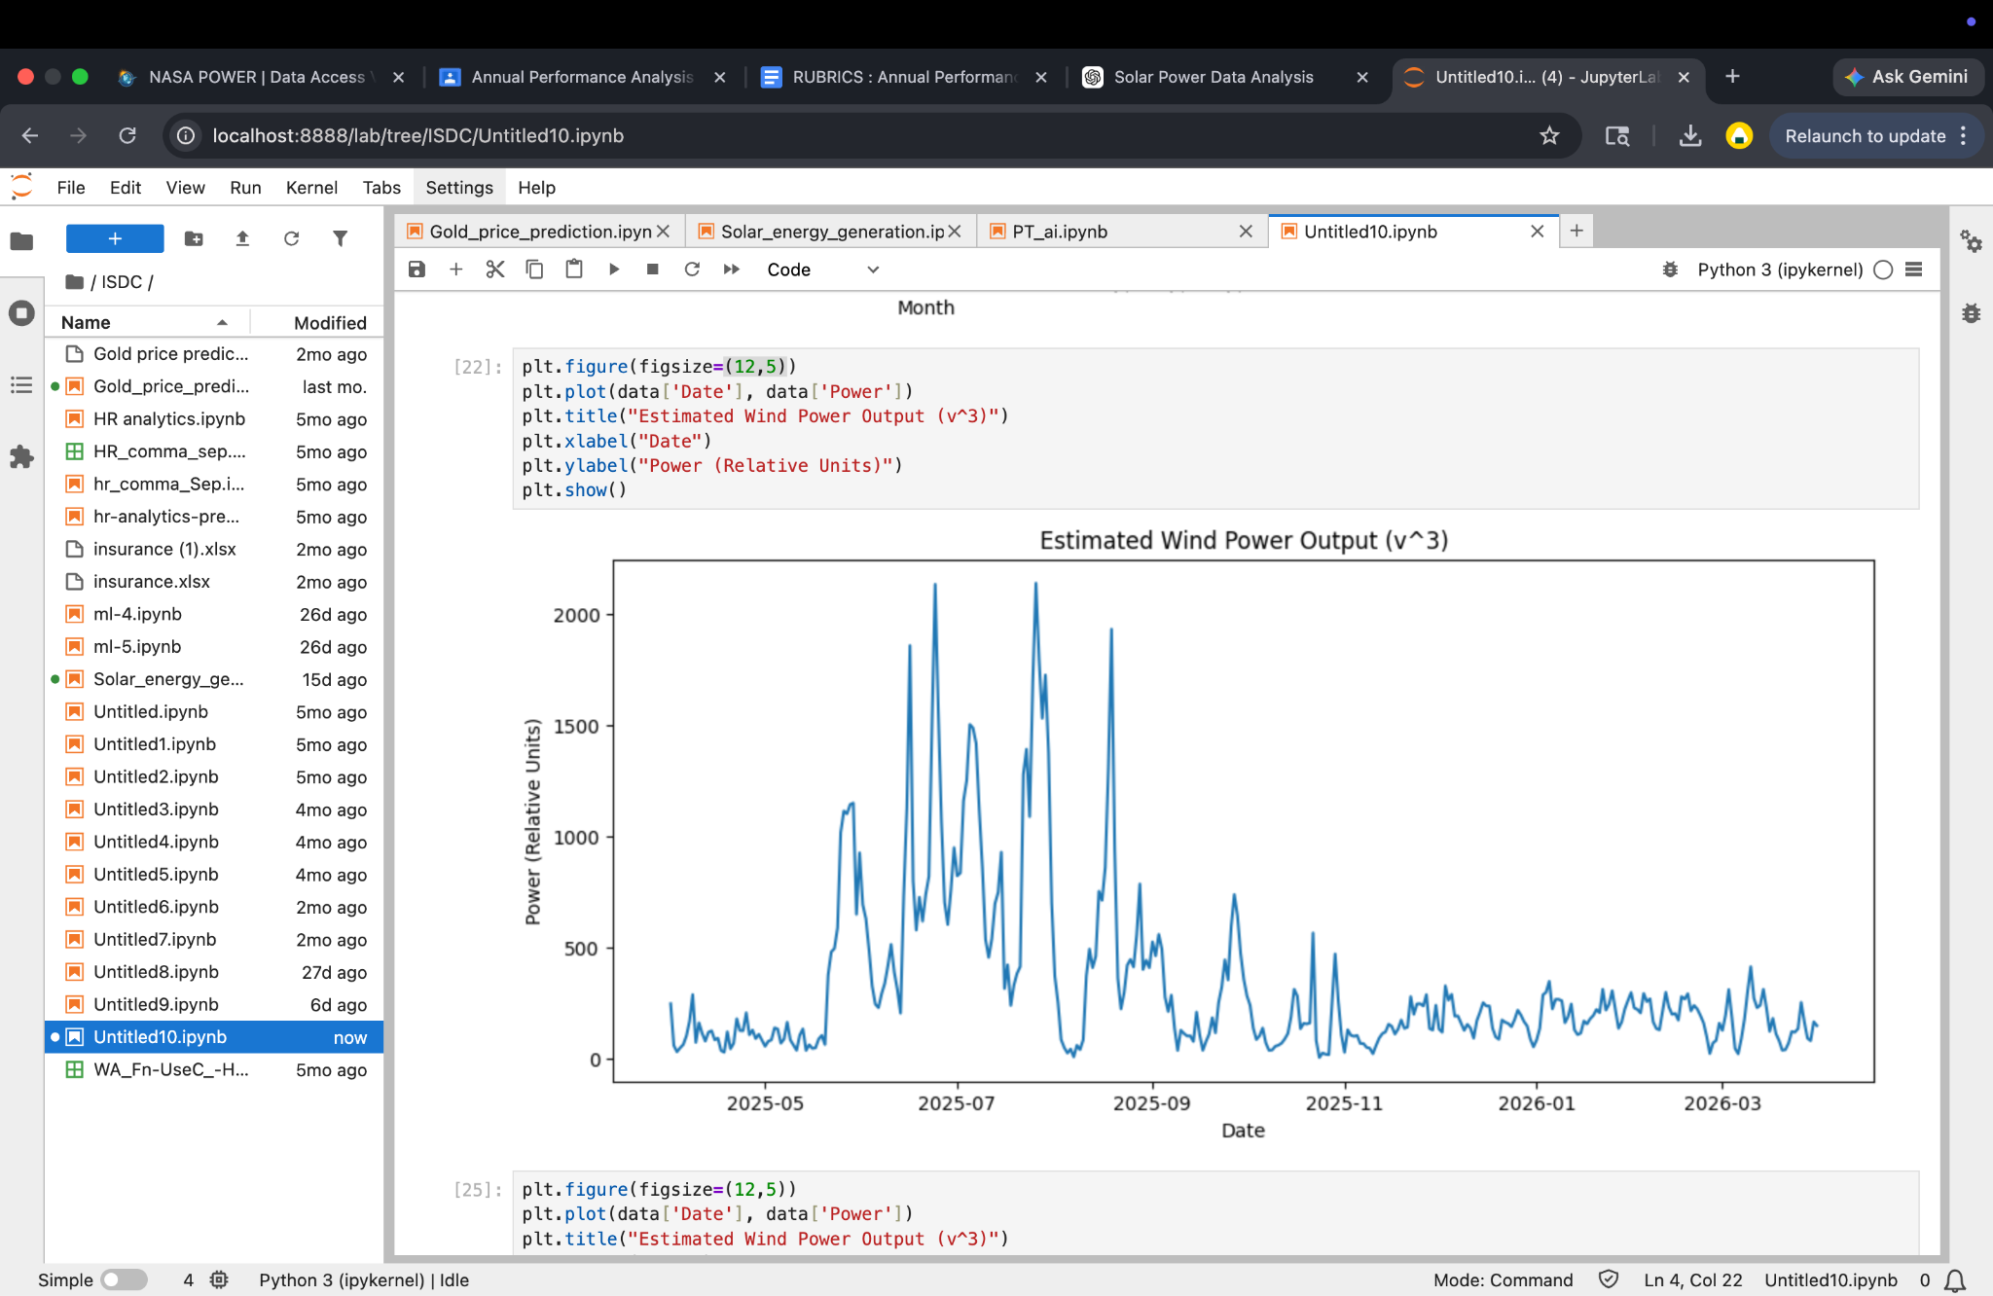
The estimated power output graph exhibits significant variability due to the cubic relationship between wind speed and power. Even small increases in wind speed result in large spikes in power output, particularly during peak wind months. This demonstrates that wind energy generation is highly sensitive to wind speed variations, and periods of strong wind can lead to disproportionately higher energy output.

Wind Speed at Different Heights (10m vs 50m)
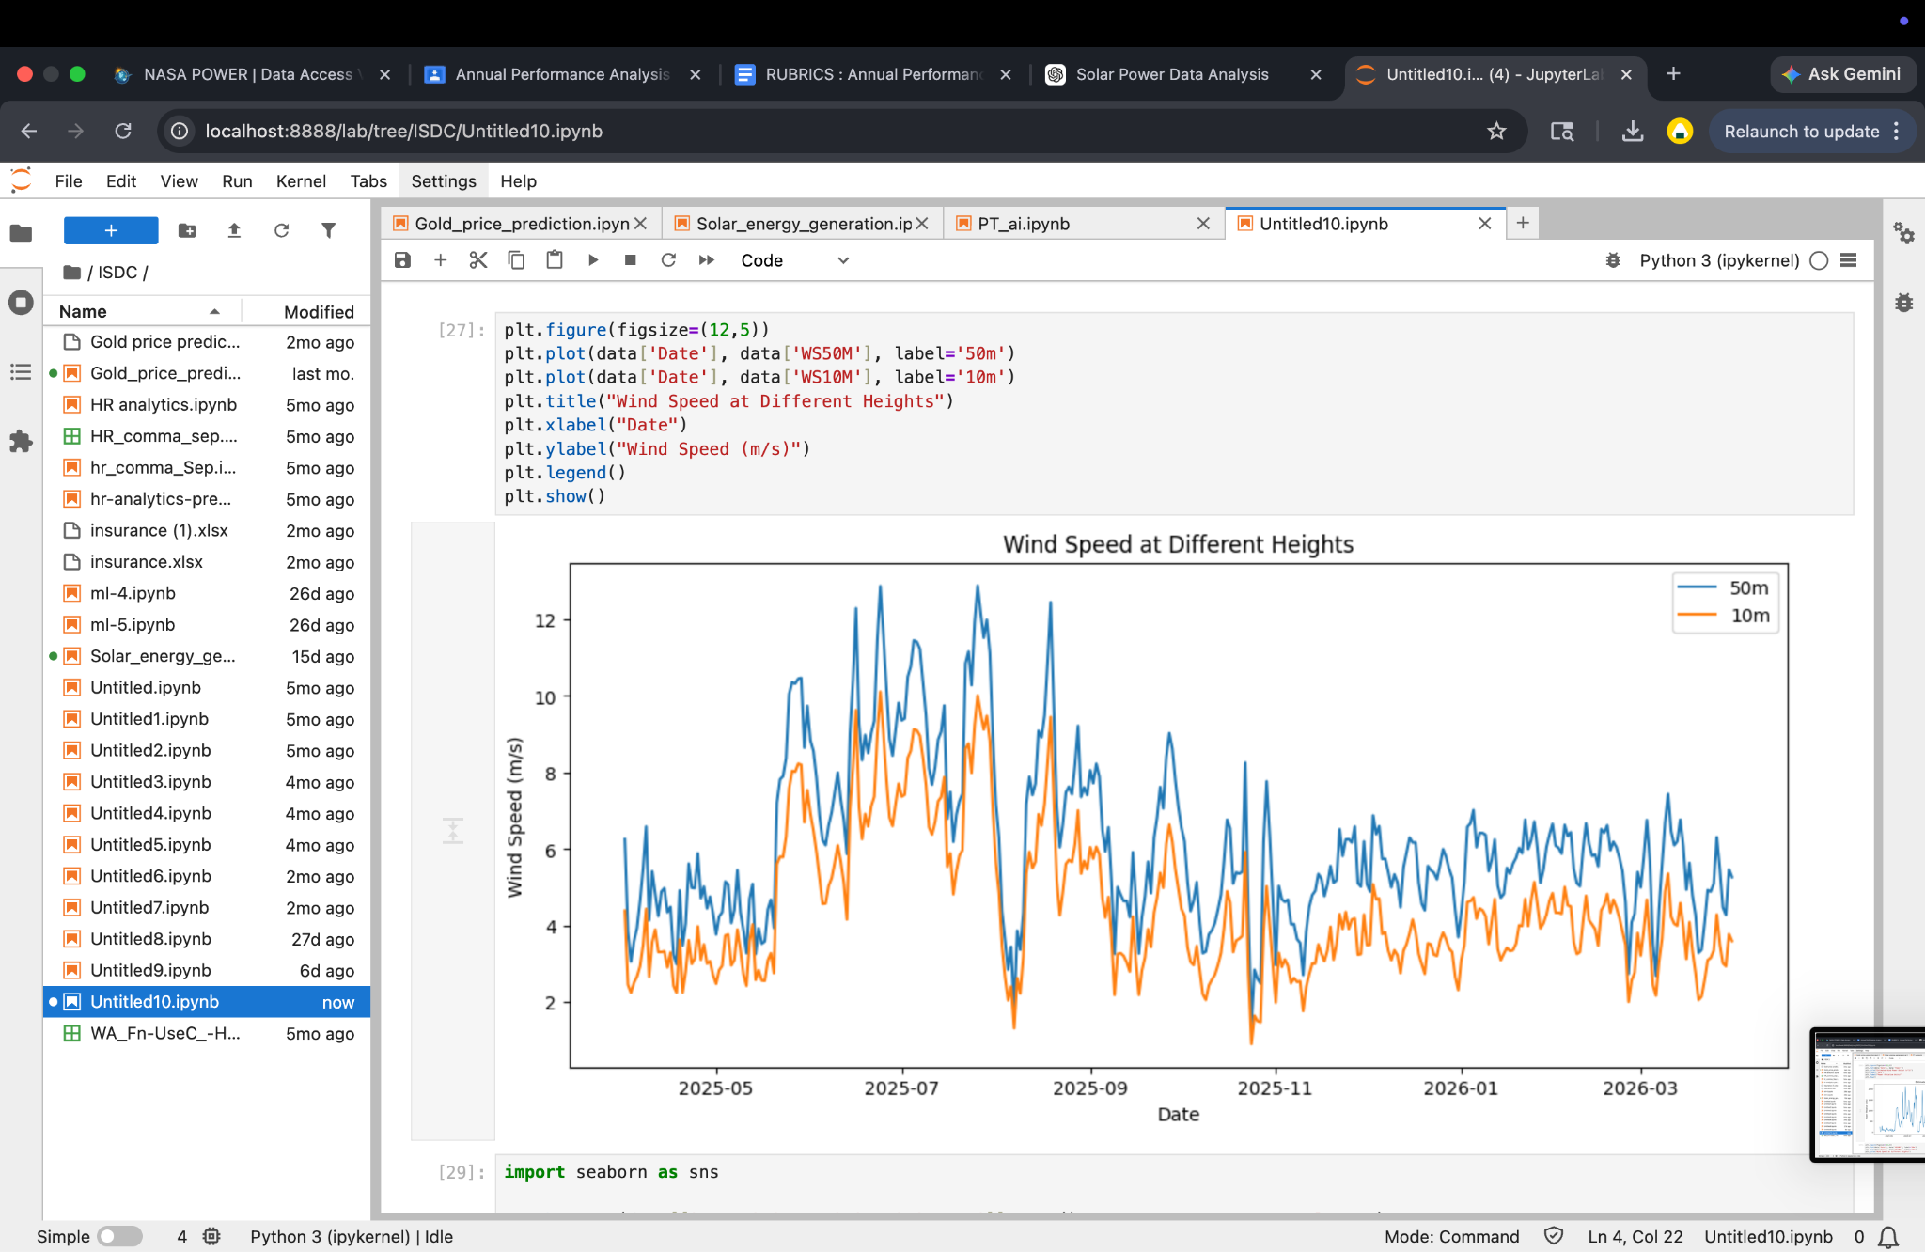
The comparison of wind speeds at 10 meters and 50 meters shows that wind speed is consistently higher at greater heights. Both curves follow a similar pattern over time, but the 50-meter wind speed remains significantly higher. This indicates that wind turbines installed at higher elevations are more efficient and capable of generating more power, reinforcing the importance of turbine height in wind energy systems.

Correlation Matrix
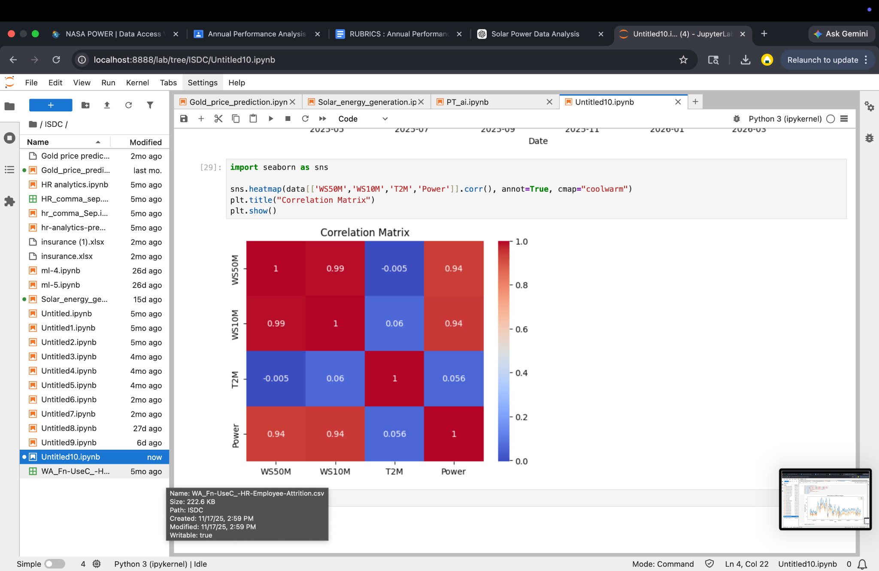

The correlation matrix reveals a very strong positive relationship between wind speed at 50 meters and 10 meters (≈0.99), indicating consistency across measurement heights. A strong positive correlation is also observed between wind speed and estimated power output (≈0.94), confirming that wind speed is the primary factor influencing energy generation. Temperature shows negligible correlation with both wind speed and power, suggesting minimal impact on wind energy production in this analysis.

Conclusion & Recommendations
The study concludes that Anantapur possesses significant potential for wind energy generation, particularly during monsoon months when wind speeds are highest. However, the variability in wind patterns indicates that energy production is not uniform throughout the year.
To improve efficiency and reliability, it is recommended that:
- Wind energy systems be complemented with energy storage solutions
- Hybrid renewable systems (wind + solar) be explored
- Further site-specific and long-term studies be conducted
With proper infrastructure and planning, Anantapur can emerge as an important wind energy hub in India.

